Little SPARK: Simple Play Adaptations to Reference for Kids

Dimpl Duo
Description: | Image:
Dimpl Duo features silicone buttons, textured shapes, and shape and color names written in English and in Braille on either side.  Purchasing Information  Demo Video | 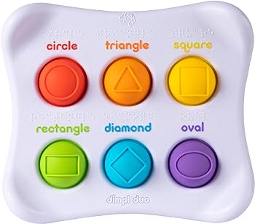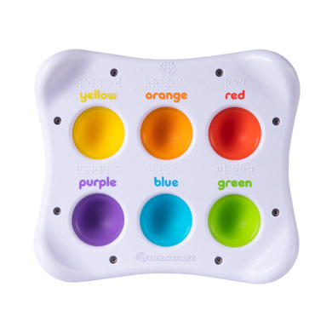

Who Might Benefit?
Those who seek sensory input throughout the day, prefer movement to focus, engage in touching, poking, or fidgeting with items to calm themselves.
Why Use?
This colorful tablet sized toy encourages sensory exploration, tactile learning, shape learning, color learning, reading skills. Dimpl Duo can also serve as a fidget, a self-regulation tool that can increase a child’s focus and attention to the task at hand or strengthen fine motor skills through finger isolation practice.
Instructions for Use: | Adaptation Ideas:
Environmental Considerations  Use in all settings during large group activities, small group activities, and one-on-one instruction.  Positioning & Alternate Positioning  - Use in any position; seated, standing, on the floor, etc. with a slanted surface or propped up.  Basic Play/Use Play Extended Play/Use  - Open ended exploration Roll a dice with colors/shapes on each side push the matching button. Explore colors and shapes and strengthen finger isolation. | Stabilize It  - Use Velcro or Dycem.  Simplify It  - Cover columns or rows to reduce the number of buttons.  Contain It  - Store sensory item choices in a basket or tub.  Add Sensory Cues  - Label colors and shapes with print words and braille in environment.  Communication Supports  - Use vocabulary such as “push” “down”, “across”, “find (insert names of colors or shapes)”.  - Visual supports like communication cards and social narratives can help a child communicate their feelings.

Words to Encourage Play/Use
Color  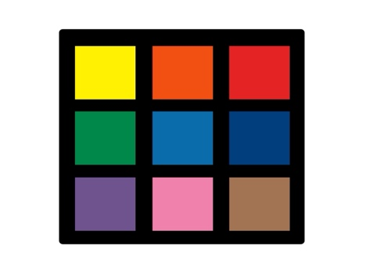 | Shape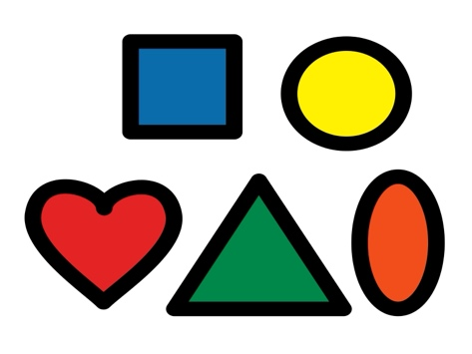 | Find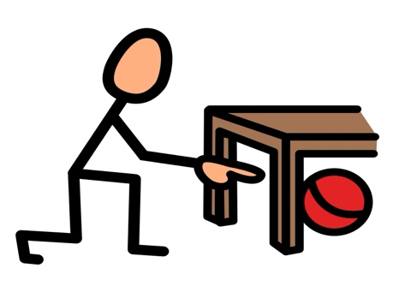
Touch | Push | Help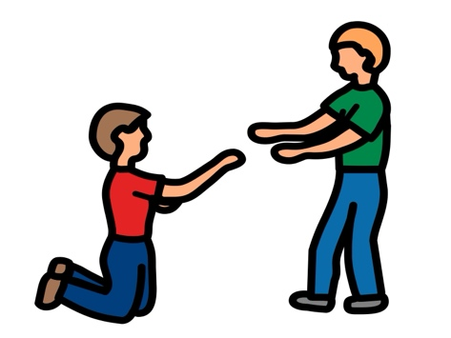
Quiet  | Calm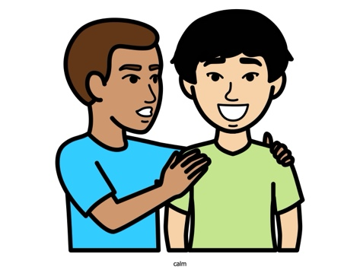 | Done  
*”Adaptations” adapted from: Haugen’s Modes for Adapting Toys based on materials from the "Let's Play" Project at the University of Buffalo
PCS is a trademark of Tobii Dynavox, LLC. All rights reserved. Used with permission.

